1. 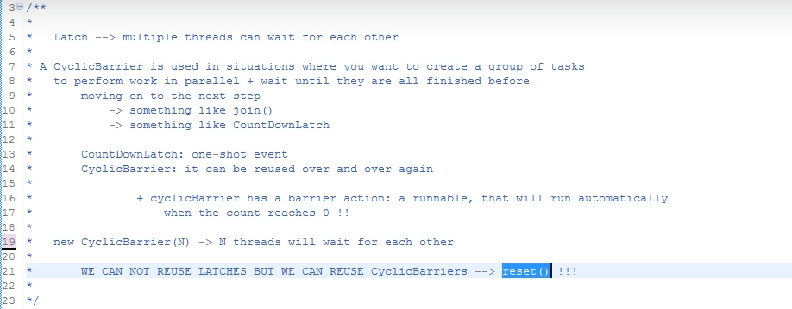
2. 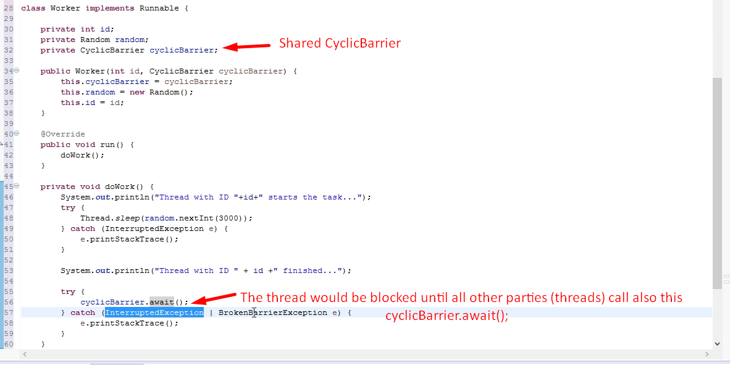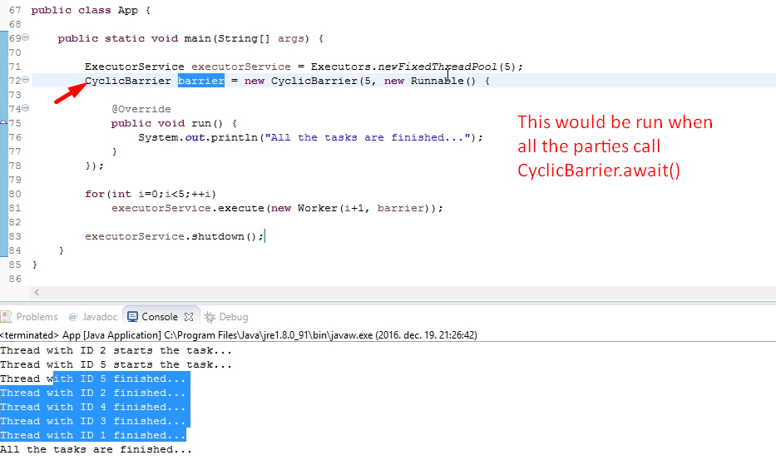
3. **Example**:
   1. 3 friends plan to go from Delhi to Goa.
   2. One by one each friend reaches the bus stand.
   3. They all wait for each other.
   4. When all reach, they sit in the bus.